**MINISTRY OF EDUCATION AND TRAINING**

**FPT UNIVERSITY**

Capstone Project Document

## System Testing Test Case

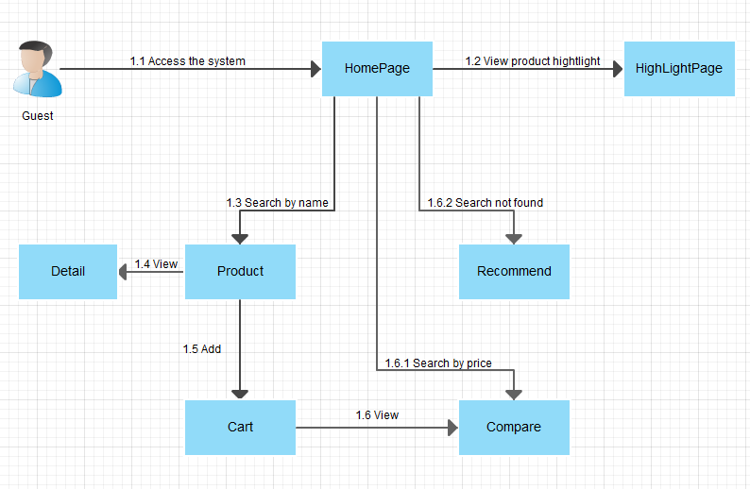

Figure 1: Guest Core Flow

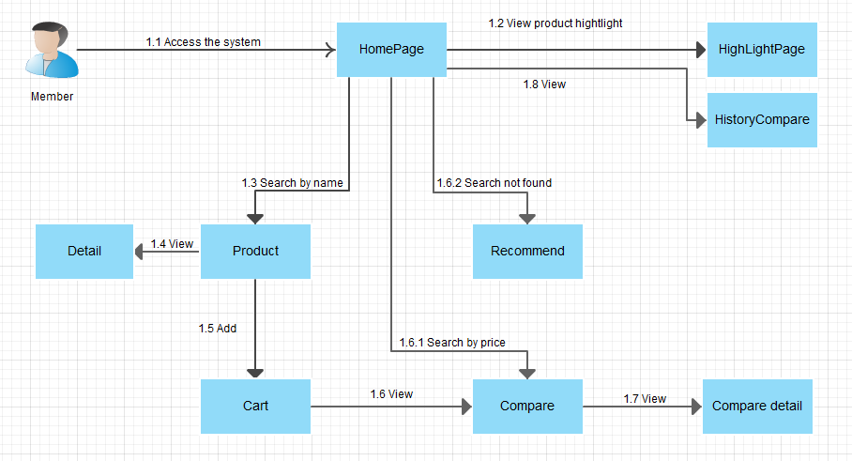

Figure 2: Member Core Flow

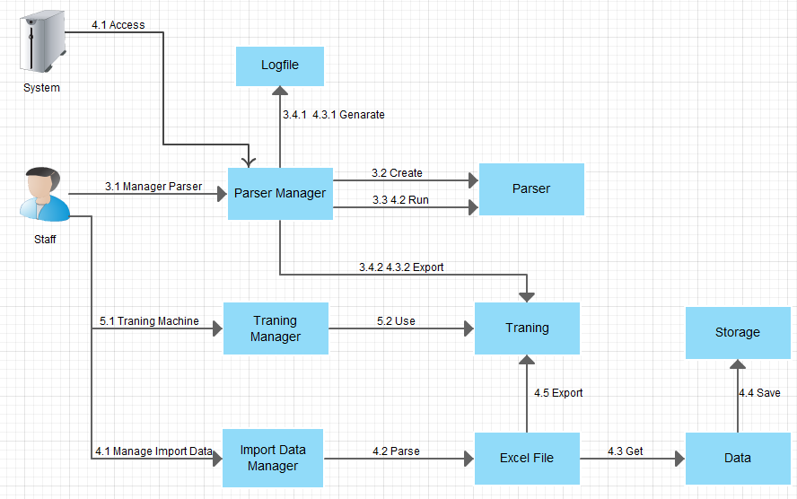

Figure 3: Staff, System Core Flow

### Guest Test Case

#### Search Product by name

|  |  |  |  |  |  |  |  |
| --- | --- | --- | --- | --- | --- | --- | --- |
| **ID** | **Test Case Description** | **Test Case Procedure** | **Expected output** | **Inter-test Case Dependence** | **Result** | **Test Date** | **Note** |
| SPN01 | Guest searches product by name. | 1 – On the home page, click on “**Tìm kiếm**” on menu bar.  2 – Input name of product on search textbox.  3 – Click “**Search**” button or press enter key. | - After step 1, go to search page  - After step 3, show search result with product name, alias name. |  | Passed | 13/08/2014 |  |
| SPN02 | Member searches product by name. | 1 – On the home page, click on “**Tìm kiếm**” on menu bar.  2 – Input name of product on search textbox.  3 – Click “**Search**” button or press enter key. | - After step 1, go to search page  - After step 3, show search result with product name, alias name. |  | Passed | 13/08/2014 |  |

Table 46: Search Product by name Test Case

#### Search Product by price

|  |  |  |  |  |  |  |  |
| --- | --- | --- | --- | --- | --- | --- | --- |
| **ID** | **Test Case Description** | **Test Case Procedure** | **Expected output** | **Inter-test Case Dependence** | **Result** | **Test Date** | **Note** |
| SPP01 | Guest searches product by price. | 1 – On the home page, click on “**Tìm kiếm**” on menu bar.  2 – Choose brand on dropdown list, choose price on dropdown list.  3 – Click “**Search**” button | - After step 1, go to search page  - After step 3, go to compare page. |  | Passed | 13/08/2014 |  |
| SPP02 | Member searches product by price. | 1 – On the home page, click on “**Tìm kiếm**” on menu bar.  2 – Choose brand on dropdown list, choose price on dropdown list.  3 – Click “**Search**” button | - After step 1, go to search page  - After step 3, go to compare page. |  | Passed | 13/08/2014 |  |

Table 46: Search Product by price Test Case

#### View Detail

|  |  |  |  |  |  |  |  |
| --- | --- | --- | --- | --- | --- | --- | --- |
| **ID** | **Test Case Description** | **Test Case Procedure** | **Expected output** | **Inter-test Case Dependence** | **Result** | **Test Date** | **Note** |
| VD01 | Guest view detail. | 1 – On the home page, click on product name result in “**SearchPage**”. | - After step 1, go to detail page. |  | Passed | 13/08/2014 |  |
| VD02 | Member view detail. | 1 – On the home page, click on product name result in “**SearchPage**”. | - After step 1, go to detail page. |  | Passed | 13/08/2014 |  |

Table 46: View Detail Test Case

#### Add To Cart

|  |  |  |  |  |  |  |  |
| --- | --- | --- | --- | --- | --- | --- | --- |
| **ID** | **Test Case Description** | **Test Case Procedure** | **Expected output** | **Inter-test Case Dependence** | **Result** | **Test Date** | **Note** |
| AC01 | Guest adds product to cart. | 1 – On the search page, click on “**+ So Sánh**” button on search result row. | - After step 1, added product to cart. | SPN01 | Passed | 13/08/2014 |  |
| AC02 | Guest adds product to cart when the product has existed in cart. | 1 – On the search page, click on “**+ So Sánh**” button on search result row. | - After step 1, update quantity of the product in cart. | SPN01, AC01 | Passed | 13/08/2014 |  |
| AC03 | Member adds product to cart . | 1 – On the search page, click on “**+ So Sánh**” button on search result row. | - After step 1, added product to cart. | SPN02 | Passed | 13/08/2014 |  |
| AC04 | Member adds product to cart when the product has existed in cart . | 1 – On the search page, click on “**+ So Sánh**” button on search result row. | - After step 1, update quantity of the product in cart. | SPN02, AC03 | Passed | 13/08/2014 |  |
| AC05 | Guest adds product to cart when the cart has 3 items. | 1 – On the search page, click on “**+ So Sánh**” button on search result row. | - After step 1, display dialog message “**Giỏ của bạn không quá 3 sản phẩm**”. | SPP01 | Passed | 13/08/2014 |  |
| AC06 | Member adds product to cart when the cart has 3 items. | 1 – On the search page, click on “**+ So Sánh**” button on search result row. | - After step 1, display dialog message “**Giỏ của bạn không quá 3 sản phẩm**”. | SPP02 | Passed | 13/08/2014 |  |

Table 47: Add To Cart Test Case

#### View Compare

|  |  |  |  |  |  |  |  |
| --- | --- | --- | --- | --- | --- | --- | --- |
| **ID** | **Test Case Description** | **Test Case Procedure** | **Expected output** | **Inter-test Case Dependence** | **Result** | **Test Date** | **Note** |
| VC01 | Guest views compare. | 1 – On the home page, click “So sánh” button on “**Giỏ hàng**” on menu bar. | - After step 1, go to view compare page and display result compare. | AC01, AC02 | Passed | 13/08/2014 |  |
| VC02 | Member views compare. | 1 – On the home page, click “So sánh” button on “**Giỏ hàng**” on menu bar. | - After step 1, go to view compare page and display result compare. | AC03, AC04 | Passed | 13/08/2014 |  |
| VC07 | Guest delete product in cart. | 1 – On the view cart page, click on “**Xóa**” button on cart list row. | - After step 1, the row is removed entirely from the table. | VC01 | Passed | 13/08/2014 |  |
| VC08 | Guest delete product in cart. | 1 – On the view cart page, click on “**Xóa**” button on cart list row. | - After step 1, the row is removed entirely from the table. | VC02 | Passed | 13/08/2014 |  |

Table 48: View Compare Test Case

#### View product highlight

|  |  |  |  |  |  |  |  |
| --- | --- | --- | --- | --- | --- | --- | --- |
| **ID** | **Test Case Description** | **Test Case Procedure** | **Expected output** | **Inter-test Case Dependence** | **Result** | **Test Date** | **Note** |
| VR01 | Guest views product hightlight. | 1 – On the home page, click on “**HightLight**” on menu bar. | - After step 1, go to hightlight product page. |  | Passed | 13/08/2014 |  |
| VR02 | Member views product hightlight. | 1 – On the home page, click on “**HightLight**” on menu bar. | - After step 1, go to hightlight product page. |  | Passed | 13/08/2014 |  |

Table 49: View hight light product Test Case

### Member Test Case

#### Compare detail

|  |  |  |  |  |  |  |  |
| --- | --- | --- | --- | --- | --- | --- | --- |
| **ID** | **Test Case Description** | **Test Case Procedure** | **Expected output** | **Inter-test Case Dependence** | **Result** | **Test Date** | **Note** |
| VCD01 | Member compare detail | 1 – On the compare, click on “**So sánh chi tiết”** button.  2 – Drap and drop line priority. | - After step 1, go to compare details page  - After step 2, show new result compares. | VC02 | Passed | 13/08/2014 |  |

Table 50: Compare detail Test Case

#### View history compare

|  |  |  |  |  |  |  |  |
| --- | --- | --- | --- | --- | --- | --- | --- |
| **ID** | **Test Case Description** | **Test Case Procedure** | **Expected output** | **Inter-test Case Dependence** | **Result** | **Test Date** | **Note** |
| VCD01 | Member view history compares. | 1 – On the menu bar, click on “**Lịch Sử So Sánh**” link. | - After step 1, go to compare history page and show compare history. |  | Passed | 13/08/2014 |  |

Table 50: History compares Test Case

### Staff Test Case

#### Manage Parser

|  |  |  |  |  |  |  |
| --- | --- | --- | --- | --- | --- | --- |
| **ID** | **Test Case Description** | **Test Case Procedure** | **Expected output** | **Result** | **Test Date** | **Note** |
| TC01 | Staff view list parsers | 1 – Login into the system using a staff account  2 – On the staff home page, click “Parser”, and then click “Danh sách các parser”. | - After step 2, parser list will be shown. | Pass | 13/08/2014 |  |
| TC02 | Staff create new parser | 1 – Login into the system using a staff account  2 – On the staff home page, click “Parser”, and then click “Tạo parser”.  3 – Fill in parser detail :   1. “Loại parser” tab 2. “Khung thông tin” tab 3. “Tên sản phẩm” tab 4. “Giá sản phẩm” tab 5. “Phân trang” tab   4 – Click “Hoàn thành” button. | - After step 4, parser will be inserted into database. | Pass | 13/08/2014 |  |
| TC03 | Staff run Parser | 1 – Login into the system using a staff account  2 – On the staff home page, click “Parser”, and then click “Danh sách các parser”.  3 – Staff clicks on “Chạy Parser” button. | - After step 3, product will be inserted into database.  + Generate log file.  + Export duplicate products to text file. | Pass | 13/08/2014 |  |

Table 54: Manage Parser Test Case

#### Manage Import Data

|  |  |  |  |  |  |  |
| --- | --- | --- | --- | --- | --- | --- |
| **ID** | **Test Case Description** | **Test Case Procedure** | **Expected output** | **Result** | **Test Date** | **Note** |
| TC04 | Staff import list product in excel file. | 1 – Login into the system using a staff account  2 – On the staff home page, click “Dữ liệu”, and then click “Nhập từ Excel”.  3 – Click “Brown” button.  4 – Select excel file.  5 – Click “Open” button.  6 – Click “Tải lên” button. | - After step 6, product list will be shown. | Pass | 13/08/2014 |  |
| TC05 | Staff edit product in error product table. | After step 6 in test case ST04  1 – On the import page, click “Danh sách sản phẩm lỗi” tab.  2 – Fill in Product detail:   1. Product Name 2. Url Image 3. CPU 4. VGA 5. HDD 6. Ram 7. Price 8. Url   3 – Click “Lưu” button. | - After step 1, error product list will be shown.  - After step 3, product will be compared with duplicate product in “Danh sách sản phẩm trùng” table and “Danh sách sản phẩm đúng” table:  + If not duplicate, product will be move to “Danh sách sản phẩm đúng” table.  + Else product will be moved to “Danh sách sản phẩm trùng” table. | Pass | 13/08/2014 |  |
| TC06 | Staff save products in excel file into database. | After step 6 in test case ST04.  1 – Click “Lưu lại” button. | - After step 1, product will be compared with database.  + If products be duplicated, products will be shown into “Danh sách sản phẩm trùng” table.  + Else, products will be saved into database. | Pass | 13/08/2014 |  |
| TC07 | Staff save file log duplicate product | After step 6 in test case ST04  1 – On the popup save correct product, check “Danh sách sản phẩm trùng” checkbox or “Danh sách sản phẩm lỗi” check box. | - After step 1, all products duplicate export to text file. | Pass | 13/08/2014 |  |

Table 55: Manage Import Data Test Case

#### Train Machine

|  |  |  |  |  |  |  |
| --- | --- | --- | --- | --- | --- | --- |
| **ID** | **Test Case Description** | **Test Case Procedure** | **Expected output** | **Result** | **Test Date** | **Note** |
| TC08 | Staff uses training file | 1 – Login into the system using a staff account.  2 – On the staff home page, click “Dữ liệu”, and then click “Xử lý dữ liệu trùng”. | - After step 2, product list in text file will be shown. | Pass | 13/08/2014 |  |
| TC09 | Staffs join products. | After step 2 in test case ST08.  1 – Click checkbox products be duplicated.  2 – Click “Gộp” button. | - After step 2, duplicate products will be joined and saved into database. | Pass | 13/08/2014 |  |
| TC10 | Staffs divide products. | After step 2 in test case ST08.  1 – Click checkbox products be duplicated.  2 – Click “Tách” button. | - After step 2, duplicate products will be divided and saved into database. | Pass | 13/08/2014 |  |
| TC11 | Staffs confirm and mapping new product | 1 – On the menubar click link “Xác nhận laptop mới”.  2- On the row include new laptop click “Kích hoạt” button.  3- On the “Kích Hoạt” popup maping laptop or hardware and lick “Lưu” button. | - After step 1, go to view confirm new laptop page and display list laptop wating confirm  -After step 2, show popup to active laptop.  - After step 3, the laptop is active on system. | Pass | 13/08/2014 |  |

Table 56: Train Machine Test Case

#### Fill Weight Hardware

|  |  |  |  |  |  |  |
| --- | --- | --- | --- | --- | --- | --- |
| **ID** | **Test Case Description** | **Test Case Procedure** | **Expected output** | **Result** | **Test Date** | **Note** |
| TC08 | Staff fill weight hardware | 1 – Login into the system using a staff account.  2 – On the staff home page, click “Fill Weight hardware” page, and then click “Xử lý dữ liệu trùng”.  3 – On the row has hardware change weight and click ”update” button | - After step 2 show list hardware weight equal zero to update new weight.  - After step 3 the hardware update new weight. | Pass | 13/08/2014 |  |

Table 56: Fill Weight Hardware Test Case